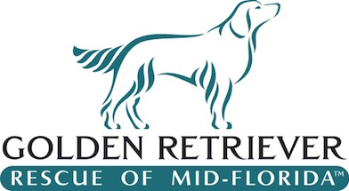
GRRMF Donation Sponsorship Form

Please print legibly or type
Date: ___________________
Name of Donor (for recognition & acknowledgment)
______________________________________________________________________
Recognition Details (name of company or organization to be recognized, if different from above):
______________________________________________________________________

Address: ______________________________________________________________________

Telephone: _____________________ E-mail: _________________________________________

Contact Person: _________________________________

Description of donated item(s):
Gift Card: Value $_______________
Gift Certificate: Value $_______________

Please mail donation and form to GRRMF P.O. Box 1449 Goldenrod, FL 32733
Questions? Email info@grrmf.org Thank you!

A COPY OF THE OFFICIAL REGISTRATION AND FINANCIAL INFORMATION MAY BE OBTAINED FROM THE DIVISION OF CONSUMER SERVICES B Y CALLING TOLLFREE (800-435-7352) WITHIN THE STATE. REGISTRATION DOES NOT IMPLY ENDORSEMENT, APPROVAL, OR RECOMMENDATION BY THE STATE. # CH11185

